**React JS Assignment**

1. **Describe four (4) features of React JS?**
2. JSX:It stands for Javascript XML.Javascript uses JSX to use HTML as a Javascript extension syntax to describe the structure and appearance of UI components.JSX code is then transformed into regular Javascript using a transpiler like Babel.They make it easier

To create and manipulate the user interface in React application.

1. One way Data Binding: Data flows from parent components to child components through props .This approach ensures predictable data flow,simplifies debugging ,and improves application performance by preventing unnecessary re-renders.
2. Virtual DOM:React uses virtual DOM(Document Object Model) when there is a change in the component’s state, React updates the virtual DOM and calculates the minimum number of changes required to sync it with the actual DOM.In short summary check the difference that happened to the original DOM to modify the new DOM.
3. Components:These components in React JS make it easy in React where there are reusable making code organization and maintenance more efficient.

**2.Can web browsers read JSX directly without Babel? Explain your answer?**

No, Web browsers can’t read JSX without trans-piling it with Babel. JSX code needs to be transformed into regular before it can be understood and executed by web browsers. In details Babel is a transpiler that converts JSX syntax into Javascript code that browsers can understand.

**3.With help of code snippets example, explain how lists work in React?**

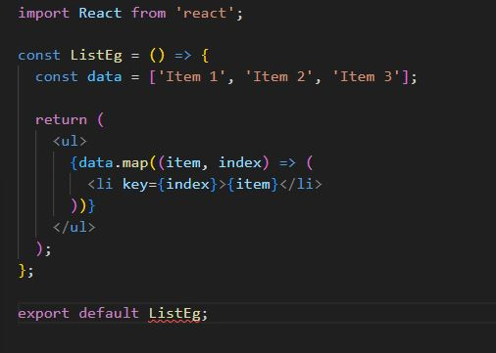

**4.Why is there a need for using keys in Lists?**

Keys are like unique identifiers for list items helping React the items that have been added,removed or rearranged.keys help React to identify each element in the list also keys improve performance .Keys must be unique.

1. **What is a state in React?**

State in React are Javascript object that holds information that can be updated and influences the rendering of the component,state can be changed over time to create interactive user interface.State can also become props when it is passed to a child component.

1. **What are props in React?**

Props are properties in full, a way to pass data from component to component .Props can’t be modified by child components,props allows communication and sharing of data between components in a React .Note that props are read-only and props can be passed from child to parent and parent to child.